Track Record
Issue 71 Services April-June 2017
Victorian transport services quarterly performance bulletin

Track Record
Victorian transport services
quarterly performance bulletin
Issue 71 Services April-June 2017

Public transport performance on metropolitan services series remained steady in the second quarter of 2017, with no significant changes in punctuality and reliability results. Regional service performance declined, with a drop in regional punctuality this quarter.
Overall satisfaction with metropolitan services decreased marginally compared with last quarter, from 68.8 per cent down to 67.7 per cent. There was no significant change compared with the June 2016 quarter.
Overall customer satisfaction with regional trains decreased slightly compared with last quarter, from 77.1 per cent down to 74.3 per cent. This was identical to the June 2016 quarter (74.3 per cent).
This information is published by Public Transport Victoria (PTV). PTV was established in 2012 and manages Victoria’s train, tram and bus services. PTV also provides a single contact for customers wanting information on public transport timetables, services, tickets and improvement projects.
Contents
Punctuality and reliability 4
Punctuality 4
Reliability 7
Quarterly City and Westona Loop Bypasses 8
Unplanned express services 8
Customer compensation 9
Payments 10
Metropolitan train and tram 10
V/Line 11
Bus 11
Customer satisfaction 12
Customer satisfaction 12
About customer satisfaction ratings 12
Overall satisfaction 13
Metropolitan trains 15
Metropolitan trams 16
Metropolitan buses 17
V/Line modes 18
V/Line coaches 20
Travel behaviour and ticketing 21
Travel behaviour 21
myki device availability 22
Fare compliance 24
Attitudes toward Authorised Officers 24
Digital products 25
Call Centre 27
Industry-wide feedback 29
About industry feedback 29
Stakeholder share 29
Industry feedback 31
PTV feedback 32

Punctuality and reliability

Punctuality
Metropolitan trains are considered on time if they arrive no more than four minutes and 59 seconds after their scheduled time in the timetable.
Metropolitan trams are considered on time if they arrive no more than 59 seconds before or four minutes and 59 seconds after the scheduled time in the timetable.
Metropolitan buses are considered on time if they arrive no more than 59 seconds before or five minutes and 59 seconds after their scheduled time in the timetable.
Long distance regional trains are considered on time if they arrive no more than 10 minutes and 59 seconds after their scheduled time in the timetable.
Short distance regional trains are considered on time if they arrive no more than five minutes and 59 seconds after their scheduled time in the timetable.
Punctuality measures do not include replacement services (that is, replacement buses and coaches) which operated during the V/Line restoration period (January – June 2016).
Note: Effective from Track Record 67, punctuality measures for metropolitan bus services have changed.
As of 1 April 2016, punctuality is measured as the proportion of services departing timing points no more than 59 seconds early and no more than 4 minutes and 59 seconds later than timetabled/scheduled. Data is collected by Victoria’s bus tracking system (BTS).
BTS systems collect information from global positioning system (GPS) devices on buses, and at approximately 20,000 bus stops across metropolitan Melbourne.
Prior to the introduction of BTS systems, data was collected through manual reporting mechanisms. Services were considered on time when they arrived no later than 5 minutes and 59 seconds late. Manual reporting was based on limited samples of 5–10 per cent of services.

Table 1: Train, tram and bus punctuality – percentage of services on-time
Mode | Threshold | Apr–Jun 2016 | Jul–Sep 2016 | Oct–Dec 2016 | Jan–Mar 2017 | Apr–Jun 2017
Metropolitan trains | 4 minutes, 59 seconds late | 92.4 | 92.6 | 91.4 | 91.9 | 91.4
Metropolitan trams – average over route | 4 minutes, 59 seconds late | 83.9 | 84.3 | 82.5 | 82.2 | 81.5
Metropolitan trams – at destination | 4 minutes, 59 seconds late | 74.2 | 74.7 | 72.1 | 72.2 | 69.5
V/Line trains | punctuality | 88.1 | 90.2 | 86.2 | 81.7 | 83.5
Metropolitan buses – average over route | punctuality | 79.4 | 81.4 | 79.6 | 80.1 | 80.8

Figure 1: Train, tram and bus punctuality – percentage of services on-time

Figure 1
Table 2: Metropolitan train punctuality – percentage of peak services on-time at destination
Line | Apr-Jun 2016 | Jul-Sep 2016 | Oct-Dec 2016 | Jan-Mar 2017 | Apr-Jun 2017
Alamein | 90.4% | 92.7% | 89.0% | 91.5% | 91.8%
Belgrave | 80.3% | 81.9% | 82.5% | 86.9% | 86.9%
Craigieburn | 91.3% | 91.1% | 88.7% | 88.5% | 89.7%
Cranbourne | 83.9% | 85.8% | 84.9% | 85.0% | 81.7%
Frankston | 93.5% | 90.7% | 89.1% | 88.6% | 88.7%
Glen Waverley | 94.9% | 94.8% | 95.2% | 95.7% | 94.1%
Hurstbridge | 91.9% | 93.3% | 92.1% | 92.6% | 91.9%
Lilydale | 85.4% | 86.8% | 84.8% | 89.7% | 89.5%
Pakenham | 86.0% | 86.5% | 87.0% | 87.4% | 84.3%
Sandringham | 94.1% | 93.7% | 95.8% | 95.7% | 94.6%
South Morang | 94.8% | 95.2% | 94.0% | 93.8% | 93.6%
Stony Point | 94.4% | 87.8% | 87.7% | 83.6% | 72.6%
Sunbury | 91.3% | 91.6% | 90.8% | 88.8% | 88.5%
Upfield | 93.7% | 94.1% | 91.8% | 90.2% | 89.8%
Werribee | 91.0% | 93.0% | 91.0% | 90.6% | 91.1%
Williamstown | 94.3% | 94.7% | 93.0% | 93.2% | 92.1%
Network total | 90.7% | 91.1% | 90.1% | 90.6% | 89.9%
Table 3: Metropolitan train punctuality – percentage of off-peak services on-time at destination
Line | Apr-Jun 2016 | Jul-Sep 2016 | Oct-Dec 2016 | Jan-Mar 2017 | Apr-Jun 2017
Alamein | 93.7% | 94.7% | 93.3% | 93.9% | 93.7%
Belgrave | 89.3% | 89.9% | 91.3% | 92.7% | 93.4%
Craigieburn | 93.3% | 93.5% | 91.9% | 90.6% | 92.5%
Cranbourne | 88.2% | 87.7% | 87.4% | 89.1% | 84.5%
Frankston | 94.6% | 92.2% | 88.9% | 88.5% | 88.9%
Glen Waverley | 97.7% | 97.9% | 96.7% | 97.7% | 97.3%
Hurstbridge | 94.6% | 94.5% | 93.4% | 94.7% | 93.5%
Lilydale | 90.9% | 92.4% | 90.6% | 93.5% | 93.2%
Pakenham | 86.5% | 87.5% | 86.0% | 86.1% | 84.6%
Sandringham | 95.8% | 95.3% | 96.5% | 95.7% | 95.4%
South Morang | 94.2% | 95.3% | 94.4% | 95.2% | 94.4%
Stony Point | 96.4% | 92.9% | 90.5% | 87.4% | 86.9%
Sunbury | 93.7% | 93.7% | 91.8% | 91.2% | 92.2%
Upfield | 94.8% | 95.1% | 93.1% | 93.3% | 92.0%
Werribee | 94.1% | 93.8% | 91.8% | 93.3% | 91.9%
Williamstown | 95.8% | 96.0% | 93.9% | 95.1% | 95.1%
Network total | 93.3% | 93.4% | 92.0% | 92.6% | 92.1%

Reliability
Metropolitan train reliability is measured as the percentage of the timetable that is delivered. Non-delivery of services includes cancellations, trains that run short and trains that bypass the City or Altona Loops.
Metropolitan tram reliability is based on the percentage of the timetable delivered. Non-delivery of services includes cancellations and trams that run short.
Metropolitan bus reliability is the percentage of services that operate and are completed.
Regional train reliability is measured as the percentage of scheduled services that are delivered.
Reliability measures do not include replacement services (that is, replacement buses and coaches) which operated during the V/Line restoration period (January – June 2016).
Table 4: Train, tram and bus reliability – percentage of timetable delivered
Mode | Measure | Apr-Jun 2016 | Jul-Sep 2016 | Oct-Dec 2016 | Jan-Mar 2017 | Apr-Jun 2017
Metropolitan trains | % timetable delivered | 98.8 | 98.8 | 98.6 | 98.9 | 99.0
Metropolitan trams | % timetable delivered | 98.8 | 98.9 | 98.7 | 98.4 | 98.4
V/Line trains | % services delivered | 98.1 | 98.3 | 97.9 | 96.8 | 98.4
Metropolitan buses | % services delivered | >99.9 | >99.9 | >99.9 | >99.9 | >99.9
Figure 2: Train, tram and bus reliability – percentage of timetable delivered

Quarterly City and Westona Loop Bypasses
Table 5: Quarterly City and Westona Loop Bypasses
Line | Q2  2016 | Q3  2016 | Q4 2016 | Q1 2017 | Q2 2017 | Services scheduled to run through the loop Q2 2017
Alamein | 61 | 57 | 55 | 55 | 83 | 1,281
Belgrave | 108 | 105 | 88 | 68 | 114 | 4,277
Craigieburn | 18 | 16 | 43 | 23 | 22 | 6,345
Cranbourne | 204 | 168 | 190 | 197 | 201 | 3,524
Frankston | 107 | 125 | 123 | 150 | 197 | 3,866
Glen Waverley | 41 | 43 | 63 | 39 | 63 | 3,844
Hurstbridge | 11 | 39 | 15 | 20 | 12 | 6,039
Lilydale | 166 | 173 | 156 | 134 | 216 | 6,657
Pakenham | 204 | 165 | 194 | 214 | 198 | 6,448
Sandringham | 24 | 21 | 16 | 16 | 21 | 1,300
South Morang | 13 | 37 | 10 | 26 | 16 | 5,628
Sunbury | 14 | 11 | 44 | 8 | 25 | 6,361
Upfield | 12 | 11 | 31 | 13 | 15 | 4,716
Werribee (Delivered Bypassing City Loop) | 7 | 10 | 5 | 6 | 15 | 92
Werribee (Delivered Bypassing Westona Loop) | 72 | 86 | 111 | 78 | 87 | 8,224
Werribee (Delivered Bypassing Both Loops) | – | 3 | – | – | – | 1,291
Grand Total | 1,062 | 1,070 | 1,144 | 1,047 | 1,285 | 69,893

There were 1198 bypasses of the City Loop this quarter, which is 1.9 per cent of the 61,669 services scheduled to run through the loop during this time.
There were 87 bypasses of the Westona Loop, which is 1 per cent of the 8,224 services scheduled to run through the loop during this time.

Unplanned express services
Table 6: Quarterly unplanned express services
Measure | Apr-Jun 2016 | Jul-Sep 2016 | Oct-Dec 2016 | Jan-Mar 2017 | Apr-Jun 2017
Total number of timetabled services | 192,284 | 194,826 | 193,373 | 193,240 | 190,478
Number of express run services | 46 | 18 | 5 | 7 | 1
Percentage of total services run as unplanned express | 0.0 | 0.0 | 0.0 | 0.0 | 0.0
The percentage of services run as unplanned express over the June 2017 quarter was 0.00052 per cent.

Customer compensation
Train and tram operators are expected to deliver a punctual and reliable service for customers.
PTV insists that operators do everything they can to deliver services in line with the agreed timetable.
Where operators fall short, they are required to pay compensation to customers, in the form of complimentary travel. Only customers who travel with a periodical ticket of four weeks or more are eligible to receive compensation.
Table 7: Service level thresholds for compensation (per cent)
Measure | Threshold | Trains | Trams | V/Line
Punctuality | Arrival by 4 minutes, 59 seconds | 88 | 77 | -
 | Arrival by 5 minutes, 59 seconds | - | - | 92*
Reliability | Percentage of timetable delivered | 98 | 98 | -
 | Percentage of services delivered | - | - | 96
* For long distance V/Line services, on-time arrival is defined as arriving no later than 10 minutes and 59 seconds after the timetabled arrival time
Metropolitan trains
Customer compensation was not paid for metropolitan trains this quarter.
Metropolitan trams
Customer compensation was not paid for metropolitan trams this quarter.
V/Line
In April, passenger compensation is payable on all lines except Shepparton, and Swan Hill and Echuca as punctuality was below the applicable threshold (92.0 per cent). Compensation is not payable for reliability on all lines as performance was above the applicable threshold (96.0 per cent).
In May ,passenger compensation is payable on all lines except Albury as punctuality was below the applicable threshold (92.0 per cent). Compensation is payable for reliability on the Albury line as performance was below the applicable threshold (96.0 per cent).
In June, passenger compensation is payable on all lines as punctuality was below the applicable threshold (92.0 per cent). Compensation is not payable for reliability on all lines as performance was above the applicable threshold (96.0 per cent).

Payments

Metropolitan train and tram
Metro Trains and Yarra Trams receive regular payments from Public Transport Victoria to cover the delivery of services and the operation and development of the networks. The terms of these payments are outlined in operator franchise agreements.
PTV requires that operators meet agreed performance targets. Penalties or incentives are paid depending on how operators perform against these targets.
Incentive payments are based on a detailed measure of the passenger impact of service disruptions. These include delays, cancellations, short services and a number of other disruption types (including trains that bypass the City and/or Westona loops).
Each disruption is multiplied by an agreed 'passenger weighting' for that service which depends on the route, the time of day, and the direction of the service. Longer delays result in higher penalties. Operators can receive bonus payments or incur penalties depending on whether the level of disruption is above or below agreed levels in the contracts.
Table 8: Metropolitan train payments ($'000s)
Payment type | Apr-Jun 2016 | Jul-Sep 2016 | Oct-Dec 2016 | Jan-Mar 2017 | Apr-Jun 2017
Base contract | 59,471 | 55,808 | 61,614 | 52,676 | 65,807
Incentive or penalty | 2,127 | 2,544 | 3,444 | 3,259 | 1,797
Customer Experience Performance Regime | 0 | 0 | 0 | 0 | 0
Revenue Reset Adjustment Payment | 28,954 | 20,636 | 20,636 | 30,461 | 30,799
Maintenance and projects¹ | 64,213 | 63,495 | 61,119 | 63,167 | 69,934
Rolling stock² | 19,688 | 29,445 | 22,543 | 21,773 | 23,699
Operations and systems³ | 12,233 | 17,322 | 14,718 | 12,985 | 15,047
TOTAL | 186,685 | 189,250 | 184,074 | 184,321 | 207,084
¹ Maintenance and projects combines maintenance and capital projects payments
² Rolling stock payments include rolling stock adjustments and exams
³ Operations and systems include payments for business system upgrades, driver establishment, electricity, and employee entitlements
Table 9: Metropolitan tram payments ($'000s)
Payment type | Apr-Jun 2016 | Jul-Sep 2016 | Oct-Dec 2016 | Jan-Mar 2017 | Apr-Jun 2017
Base contract | 480 | 4,168 | 7,222 | -2,148 | -2,835
Incentive and penalty | -1,220 | -120 | -1,221 | -586 | -1,541
Customer Experience Performance Regime | 0 | 0 | 444 | 0 | 0
Revenue Reset Adjustment Payment | 17,859 | 20,745 | 20,745 | 19,237 | 18,780
Maintenance and projects¹ | 24,549 | 11,375 | 15,880 | 11,038 | 11,782
Rolling stock | 8,767 | 8,767 | 8,429 | 7,527 | 6,738
Operations and systems² | 3,104 | 3,213 | 8,511 | 3,178 | 3,338
TOTAL | 53,539 | 48,148 | 60,009 | 38,246 | 36,261
¹ Maintenance and projects combines maintenance and capital projects payments
² Operations and systems payments include business system upgrades, electricity and employee entitlements

V/Line
Regional coach payments are made to V/Line, which is a state-owned enterprise, however regional train payments and penalties have ceased following the signing of the V/Line services agreement.
Table 10: Regional train and coach payments ($'000s)
Payment type | Apr-Jun 2016 | Jul- Sep 2016 | Oct- Dec 2016 | Jan-Mar 2017 | Apr-Jun 2017
Base contract | 129,836 | 132,052 | 129,469 | 113,494 | 81,379
Regional Coaches | 8,573 | 0 | 0 | 0 | 0
Farebox | 21,508 | 22,698 | 23,299 | 25,623 | 23,876
Rolling stock | 8,953 | 8,953 | 8,953 | 8,953 | 8,953
Total | 168,870 | 163,703 | 161,721 | 148,071 | 114,208

Bus
PTV has individual contracts with bus operators to run services in Melbourne and regional areas. Payments are made to these operators to help deliver route and school bus services.
Table 11: Metropolitan, regional and school bus payments ($'000s)
Payment type | Apr-Jun 2016 | Jul-Sep 2016 | Oct-Dec 2016 | Jan- Mar 2017 | Apr-Jun 2017
Metropolitan | 146,975 | 150,621 | 151,528 | 155,331 | 153,429
Regional | 29,114 | 28,880 | 29,541 | 30,707 | 31,633
School | 56,113 | 57,306 | 57,318 | 39,159 | 58,220
Total | 232,201 | 236,808 | 238,387 | 225,198 | 243,282

Customer satisfaction
Overall satisfaction with metropolitan services is measured in a six-point scale. It declined marginally in the June quarter, from a score of 68.8 to 67.7 for the June quarter. There was no significant change compared with the June 2016 quarter (Score of 67.3).
Overall customer satisfaction with regional trains decreased significantly compared with last quarter, from a score of 77.1 to 74.3 for the June quarter. This was a significant increase compared to the June 2016 quarter (74.5).

Customer satisfaction
Overall satisfaction with metropolitan trains decreased slightly compared with last quarter, down from a score of 73.5 for March 2017 to 72.7 for June 2017. This was an increase on the June 2016 quarter score of 70.9.
Compared with last quarter, there was a minor change in satisfaction with Running of Services from 74.1 for March to 74.0 for June 2017 .
Overall satisfaction with metropolitan trams increased slightly compared in the last quarter, from a score 76.2 for the March 2017 quarter to 76.4 for June quarter 2017. This was also a slight increase on the March 2016 quarter score of 75.2.
Compared with the last quarter, there was a marginal increase in satisfaction with personal security from a score of 74.5 for the March 2017 quarter to 74.8 for June 2017 quarter.
Overall satisfaction with metropolitan buses decreased slightly compared with last quarter, from a score of 76.7 for the March 2017 Quarter to 75.9 for the June 2017 Quarter. This was nevertheless a slight increase compared to the June 2016 Quarter Score of 76.0.
Compared with the March 2017 quarter, there was a minor decrease in satisfaction with Running of Services from a Score of 73.3 for March quarter 2017 to 72.9 for June quarter 2017.
Overall customer satisfaction with regional trains decreased from a score of 77.1 for the March 2017 quarter to 74.3 for the June 2017 quarter. This was a similar score to June 2016 score of 74.5.
Compared with the March 2017 quarter, Running of Services remained steady at a score of 71.8 for June 2017.
Overall customer satisfaction with regional coaches decreased slightly compared with last quarter, from 82.9 for March 2017 to 82.8 for June 2017. There was an increase compared with the June 2016 quarter 78.4

About customer satisfaction ratings
All results except overall metropolitan satisfaction (six-point scale) are reported in a 0-10 scale. Results prior to April 2009 were reported on a six-point scale.

Overall satisfaction
Table 12: Metropolitan public transport modes overall satisfaction
Apr – Jun 2015 | Jul – Sep 2015 | Oct – Dec 2015 | Jan – Mar 2016 | Apr – Jun 2016 | Jul – Sep 2016 | Oct – Dec 2016 | Jan – Mar 2017 | Apr – Jun 2017
68.1 | 67.3 | 67.8 | 69.6 | 69.0 | 68.5 | 67.5 | 68.8 | 67.7
Note: These results are still presented in the six-point scale.
Figure 3: Metropolitan public transport modes overall satisfaction (six-point scale)
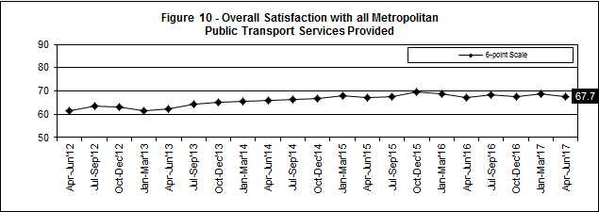
Table 13a: Metropolitan trains individual overall satisfaction
Mode | Apr – Jun 2015 | Jul – Sep 2015 | Oct – Dec 2015 | Jan – Mar 2016 | Apr – Jun 2016 | Jul – Sep 2016 | Oct – Dec 2016 | Jan – Mar 2017 | Apr – Jun 2017
Metropolitan Trains | 71.2 | 71.4 | 73.5 | 73.5 | 70.9 | 71.7 | 72.6 | 73.5 | 72.7

Figure 4: Metropolitan trains individual overall satisfaction
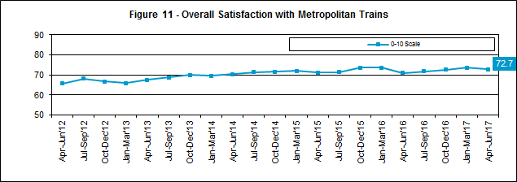

Table 13b: Metropolitan trams individual overall satisfaction
Mode | Apr – Jun 2015 | Jul – Sep 2015 | Oct – Dec 2015 | Jan – Mar 2016 | Apr – Jun 2016 | Jul – Sep 2016 | Oct – Dec 2016 | Jan – Mar 2017 | Apr – Jun 2017
Metropolitan Trams | 75.2 | 75.6 | 77.1 | 76.3 | 75.2 | 76.4 | 76.4 | 76.2 | 76.4

Figure 5: Metropolitan trams individual overall satisfaction
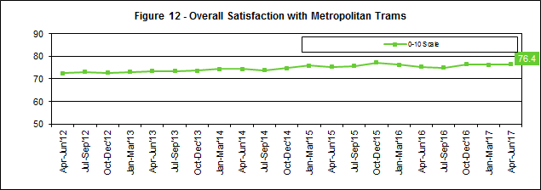
Table 13c: Metropolitan buses individual overall satisfaction
Mode | Apr – Jun 2015 | Jul – Sep 2015 | Oct – Dec 2015 | Jan – Mar 2016 | Apr – Jun 2016 | Jul – Sep 2016 | Oct – Dec 2016 | Jan – Mar 2017 | Apr – Jun 2017
Metropolitan Buses | 76.5 | 76.6 | 76.9 | 76.1 | 77.7 | 76.0 | 76.1 | 76.7 | 75.9

Figure 6: Metropolitan buses individual overall satisfaction
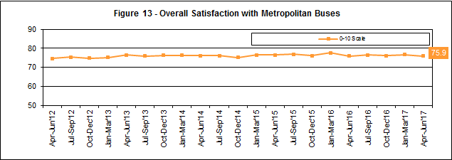

Metropolitan trains
Figure 6a: Satisfaction with key service aspects for metropolitan trains
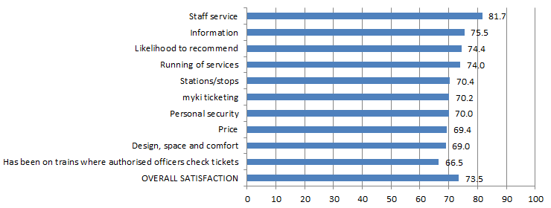
Table 14a: Satisfaction with key service aspects for metropolitan trains
Satisfaction indicator | Score | Significant change from previous quarter
Staff service | 81.7 | –
Likelihood to recommend | 74.4 | –
Information | 75.5 | –
Running of services | 74.0 | –
Personal security | 70.0 | –
Has been on trains where authorised officers check tickets | 66.5 | –
Stations/stops | 70.4 | –
Design, space and comfort | 69.0 | –
myki ticketing | 70.2 | –
Price | 69.4 | –
Overall satisfaction | 72.7 | –

Metropolitan trams
Figure 6b: Satisfaction with key service aspects for metropolitan trams
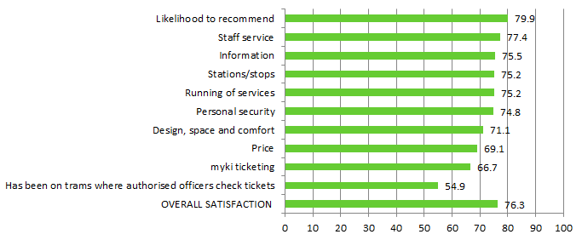Table 14b: Satisfaction with key service aspects for metropolitan trams
Satisfaction indicator | Score | Significant change from previous quarter
Likelihood to recommend | 79.9 | –
Staff service | 77.4 | –
Running of services | 75.2 | –
Stations/stops | 75.2 | –
Information | 75.5 | –
Personal security | 74.8 | –
Design, space and comfort | 71.1 | –
Price | 69.1 | –
myki ticketing | 66.7 | –
Has been on trams where authorised officers check tickets | 54.9 | –
Overall satisfaction | 76.4 | –

Metropolitan buses
Figure 6c: Satisfaction with key service aspects for metropolitan buses
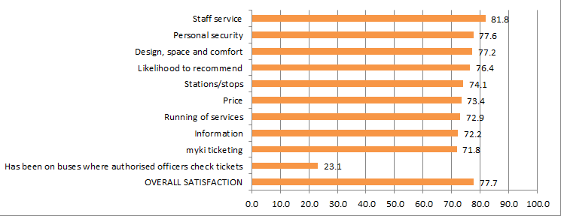Table 14c: Satisfaction with key service aspects for metropolitan buses
Satisfaction indicator | Score | Significant change from previous quarter
Staff service | 81.8 | –
Personal security | 77.6 | –
Design, space and comfort | 77.2 | –
Likelihood to recommend | 76.4 | –
Stations/stops | 74.1 | –
Information | 72.2 | –
Price | 73.4 | –
Running of services | 72.9 | –
myki ticketing | 71.8 | –
Has been on buses where authorised officers check tickets | 23.1 | –
Overall satisfaction | 75.9 | –

V/Line modes
Table 15a: V/Line trains individual overall satisfaction
Mode | Apr – Jun 2015 | Jul – Sep 2015 | Oct – Dec 2015 | Jan – Mar 2016 | Apr – Jun 2016 | Jul – Sep 2016 | Oct – Dec 2016 | Jan – Mar 2017 | Apr – Jun 2017
V/Line trains | 76.9 | 76.2 | 78.8 | 73.8 | 74.5 | 75.8 | 75.0 | 77.1 | 74.3

Table 15b: V/Line coaches individual overall satisfaction
Mode | Apr – Jun 2015 | Jul – Sep 2015 | Oct – Dec 2015 | Jan – Mar 2016 | Apr – Jun 2016 | Jul – Sep 2016 | Oct – Dec 2016 | Jan – Mar 2017 | Apr – Jun 2017
V/Line coaches | 84.6 | 85.7 | 83.9 | 86.1 | 81.6 | 78.4 | 80.8 | 82.9 | 82.8

Figure 7: V/Line individual overall satisfaction – trains and coaches
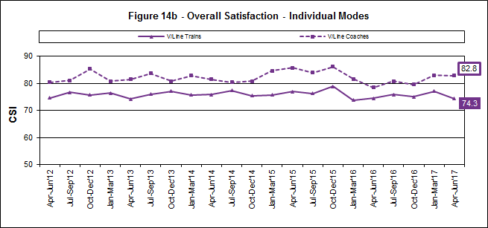

Figure 7a: Satisfaction with key service aspects for V/Line trains
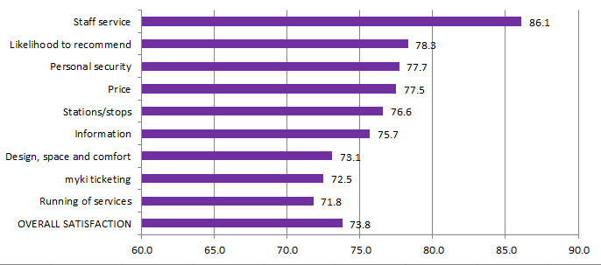
Table 16a: Satisfaction with key service aspects for V/Line trains
Satisfaction indicator | Score | Significant change from previous quarter
Staff service | 86.1 | –
Likelihood to recommend | 78.3 | –
Personal security | 77.7 | –
Information | 75.7 | Decrease
Stations/stops | 75.6 | Decrease
Price | 77.5 | –
Design space and comfort | 73.1 | Decrease
myki ticketing | 72.5 | –
Running of services | 71.8 | –
Overall satisfaction | 74.3 | Decrease

V/Line coaches
Figure 7b: Satisfaction with key service aspects for V/Line coaches
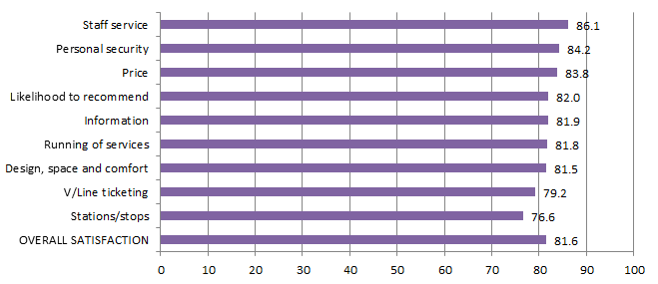
Table 16b: Satisfaction with key service aspects for V/Line coaches
Satisfaction indicator | Score | Significant change from previous quarter
Staff service | 86.1 | –
Price | 83.8 | –
Personal security | 84.2 | –
Likelihood to recommend | 82.0 | –
V/Line ticketing | 79.2 | –
Design, space and comfort | 81.5 | –
Information | 81.9 | –
Running of Services | 81.8 | –
Stations/stops | 76.6 | –
Overall satisfaction | 82.8 | –

Travel behaviour and ticketing

Travel behaviour
The proportion of non-users of public transport continued to remain relatively stable in the June 2017 quarter with 13 per cent stating they ‘hardly ever’ or ‘never use’ public transport. Usage of public transport saw an increase in occasional users (less than 3 days a week) at the expense of regular commuters.
Figure 8: Main purpose of trip on weekday and weekend

Table 17: Main purpose of trip on weekday and weekend
Purpose of trip | Weekday  (Apr – Jun 2017) | Weekend  (Apr – Jun 2017)
To get to / from work | 38% | 5%
To get to / from leisure activities | 44% | 84%
To get to / from place of study | 7% | 0%
To get errands / chores/ day to day tasks done | 28% | 17%
Something else | 1% | 2%
Source – Nature Research PTV Tracker (until June 2017)
The main purpose for using public transport on both a weekday and weekend is for leisure purposes. Across the week, there is a more even spread of reasons used public transport, with well over a third using it for work and over a quarter using it for running errands or day to day tasks.

myki device availability
A private company, NTT Data Payment Services Victoria (PSV), is under contract to the Victorian Government to operate and maintain the myki ticketing system for Victoria’s public transport network as per the new Ticketing System Services Agreement.
myki device availability measurements for the Ticketing System Services Agreement measures the availability of devices during operational shift hours only. This measure forms the bas (or unweighted) availability.
The unweighted availability is adjusted based on whether the device is unavailable during a peak period and if the device is located within the top 10 per cent of the busiest train stations (based on fare payment device volumes). This measure becomes the weighted availability (as reported below), by which PSV is assessed against.
It should be noted that 'myki reader (mobile)' excludes readers deployed on trams, as in accordance with the Ticketing System Services Agreement.
Table 18: Month-by-month NTT Data Key Performance Indicator calculated availability (per cent)
Equipment | Apr 2017 | May 2017 | Jun 2017
myki gate | 99.2899% | 99.4487% | 99.5125%
myki reader (mobile) | 99.8130% | 99.7450% | 99.7019%
myki reader (stationary) | 99.5388% | 99.6323% | 99.4320%
Note: As a consequence of the new performance methodology, the Ticketing System Services Agreement reported device availability from January 2017 onwards cannot and should not be used as a comparison to performance in December 2016 or earlier.
Figure 9: Month-by-month NTT Data Performance Indicator calculated availability (per cent)

The Victorian Government entered into a contract with a private company, NTT Data Payment Services Victoria, to operate and maintain the myki ticketing system for Victoria’s public transport network as per the new Ticketing System Services Agreement.
This contract, which came into effect on 1 January 2017, contains new key performance indicators. These new key performance indicators and the results will be published in an upcoming issue of Track Record, including data from January 2017 onwards.

Fare compliance
Attitudes toward Authorised Officers
Figure 10: Attitudes toward Authorised Officers (per cent)
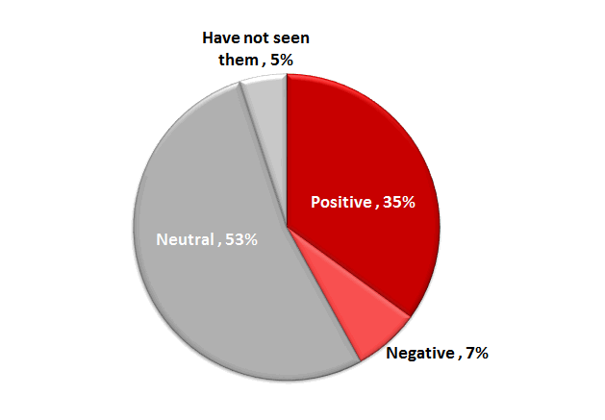
Table 19: Detailed attitudes toward Authorised Officers
Attitudes towards authorised officers | Apr-Jun 2016 | Jul-Sep 2016 | Oct-Dec 2016 | Jan-Mar 2017 | Apr-Jun 2017
Neutral | 43% | 29% | 32% | 47% | 53%
Pleased | 18% | 23% | 22% | 17% | 15%
More secure | 23% | 30% | 29% | 22% | 20%
Annoyed | 5% | 6% | 5% | 3% | 4%
Nervous | 3% | 2% | 3% | 1% | 2%
Harassed | 2% | 3% | 2% | 2% | 1%
Have not seen them | 6% | 7% | 6% | 7% | 5%
Sample size | 400 | 400 | 400 | 400 | 400
Source – Nature Research PTV Tracker (until Jun17)
Just over a third (35 per cent) of public transport users reported feeling positive towards Authorised Officers in the June 2017 quarter, down slightly from last quarter (39 per cent).
The decrease in overall positive feelings is driven by an increase in those feeling neutral (from 47 per cent last quarter to 53 per cent this quarter).
Customer service

Digital products
PTV’s website provides journey planning, timetable and ticketing information for metropolitan Melbourne and regional Victoria.
The PTV mobile phone apps for iPhones and Android handsets feature timetable and journey planning information.
Table 20: Website and app performance
 | Apr 2017 | May 2017 | Jun 2017 | Quarter total | Quarter on quarter change* | Year on year change*
Website sessions | 4.4m | 4.3m | 4.1m | 12.9m | -4.7% | +8.6%
App sessions | 6.1m | 6.5m | 6.1m | 18.7m | +7.0% | +34.6%
*The quarter total for unique visitors may be higher than the aggregate of the three months as a visitor may visit the website more than once during a month, but is only counted once in the quarter total.
PTV website
The PTV website received 12.9 million sessions from customers in the April quarter; down 4.7 per cent from the March quarter’s record total. Usage was high and consistent in April and May, before dipping in line with seasonal trends in June.
Journey planner
Customers planned some 40.6 million journeys using PTV’s journey planner across our website, mobile phone apps and call center during the quarter. This is a 0.8 per cent increase on the previous quarter, and up 14.5 per cent on the same period last year.
News and service alterations
A news article about planned bus replacements on the Cranbourne and Pakenham lines in early April was the most-viewed of the quarter (49,000 views) with other popular topics including the 2017 fare change and coach replacements on the Geelong and Warrnambool lines.
Mobile apps
Customers used PTV’s mobile apps in 18.7 million sessions during the quarter, up 34.6 per cent year-on-year.
Figure 11: Website and app sessions
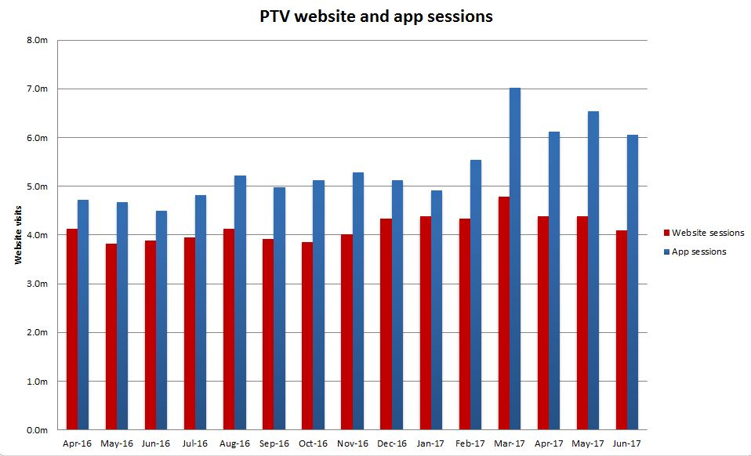
Source: Google analytics
Table 21: Website and app sessions
Month | Apr 2016 | May 2016 | Jun 2016 | Jul 2016 | Aug 2016
Website session | 4,131,197 | 3,824,990 | 3,887,248 | 1,785,687 | 1,906,603
App sessions | 4,720,286 | 4,679,908 | 4,501,484 | 4,819,738 | 5,216,392

Month | Sep 2016 | Oct 2016 | Dec 2016 | Nov 2016 | Jan 2017
Website sessions | 1,825,140 | 3,850,042 | 4,336,537 | 4,020,020 | 4,334,701
App sessions | 4,980,793 | 5,124,999 | 5,129,984 | 5,289,706 | 4,921,646

Month | Feb 2017 | Mar 2017 | Apr 2017 | May 2017 | Jun 2017
Website sessions | 4,446,234 | 4,686,265 | 4,378,338 | 4,387,262 | 4,094,648
App sessions | 5,543,405 | 7,018,876 | 6114219 | 6532869 | 6063905

Call Centre
PTV’s Call Centre provides journey and ticket information for metropolitan and regional services, as well as taking reservations and payment for V/Line tickets. It also collects feedback on behalf of all operators.
Table 22: Call Centre calls received
Measure | Apr 2017 | May 2017 | Jun 2017 | Quarter Total | Quarter on quarter change | Year on year change
Calls received | 105,754 | 89,051 | 84,003 | 278,808 | -14.2% | -8%
Call volumes decreased 14.2 per cent this quarter and decreased 8 per cent against the same period last year.
Figure 12: Call Volumes and Grade of Service (per cent)

Table 23: Call Volumes and Grade of Service (per cent)
Calls | Jun 2016 | Jul 2016 | Aug 2016 | Sep 2016 | Oct 2016 | Nov 2016 | Dec 2016 | Jan 2017 | Feb 2017 | Mar 2017 | Apr 2017 | May 2017 | Jun 2017
offered | 99,067 | 97,550 | 95,861 | 101,457 | 100,380 | 99,164 | 113,444 | 110,233 | 99,327 | 115,463 | 105,754 | 89,051 | 84,003
answered | 96,002 | 93,895 | 92,332 | 97,800 | 96,557 | 95,049 | 108,283 | 104,094 | 93,694 | 111,456 | 101,105 | 85,988 | 81,350
GOS% | 82% | 79% | 81% | 81% | 82% | 80% | 78% | 75% | 74% | 84% | 82% | 83% | 83%
The Grade of Service (GOS) target of 80 per cent of calls answered within 30 seconds was met in April (82 per cent), May (83 per cent) and June (83 per cent).

Industry-wide feedback

About industry feedback
Feedback data from all operators who have Resolve (Metro, Yarra, V/Line and PTV), is collected in a central database to aid industry-wide reporting and analysis. Bus data is provided to PTV by BusVic on behalf of its members.

Stakeholder share
During the June quarter, stakeholders reported receiving 22,506 cases (excluding special needs booking requests); this was a 13 per cent decrease on the previous quarter, and yet up by 5 per cent year-on-year.
PTV received 4,131 primary cases during the quarter; a 20 per cent decrease on the previous quarter, and an increase of 5 per cent year-on-year.
Figure 13: Resolve – Stakeholder share
Table 24: Resolve – Stakeholder share
Operator | Total number of cases | Share of all cases | Quarter-on-quarter change | Year-on-year change
Metro Trains | 5,483 | 24% | -7% | -4%
Yarra Trams | 3,451 | 15% | 7% | 6%
Bus | 6,339 | 28% | -18% | 13%
V/Line | 3,102 | 14% | -19% | 4%
Public Transport Victoria | 4,131 | 18% | -20% | 9%
Total | 22,506 | 100% | -13% | 5%
* Special needs booking requests have been removed
Types of feedback
Figure 14: Types of feedback

Table 25: Types of feedback
Feedback type | Percentage
Complaint | 78.7
Compliment | 3.4
Enquiry | 6.3
Suggestion | 2.6
Others | 9.0

Industry feedback
Figure 15: Top five feedback issues across the industry

Note: Top issues for cases entered into the Resolve database (excluding performance-based compensation claims and compliments).
Table 26: Top five feedback issues across the industry
Issue | Percentage
Service delivery | 32.1
Infrastructure | 17.0
Provision of information | 16.5
Staff | 14.8
Ticketing and policy | 7.0
Note: Top issues for cases entered into the Resolve database (excluding performance-based compensation claims and compliments).
Table 27: Breakdown of top industry issue*
Issue | Percentage
Delayed | 23.1
Service Disruption | 18.2
Overcrowding | 11.8
Service Change Needed | 9.3
System Improvement | 8.1
*Top industry feedback issue: Provision of information – 33.7 per cent of cases
Note: Bus industry feedback categorisation does not currently allow for analysis beyond the top PTV issues feedback.

PTV feedback
Excluding compliments, ‘Provision of information’ was the top feedback issue of the quarter, accounting for nearly 34 per cent of PTV cases.
Mobile Products accounted for 45 per cent of the feedback received under ‘Provision of information’.
51 per cent of the feedback came from the iPhone - PTV App 3.1.0. Issues consist of:
> Train Real time
> Accuracy
> Future Enhancement.
Service delivery accounted for 24 per cent of all PTV Cases. Requests include:
> System improvement
> Service change needed
> Modal coordination.
Some 1.33 per cent of cases received during the quarter were compliments. The top compliments were Staff and Undefined (accounting for 51 per cent of compliments).
> 71 per cent of the compliments from Staff related to Call Centre
> 40 per cent of the compliments from Undefined related to myki – product.
Figure 16: PTV top five feedback issues

Note: Bus industry feedback categorisation does not currently allow for analysis beyond the top PTV issues feedback.
Table 28: PTV top five feedback issues
Issue | Percentage
Provision of information | 33.7
Service delivery | 24.0
Infrastructure | 18.2
Ticketing and policy | 17.4
Staff | 3.7
Note: Top issues for cases entered into the Resolve database (excluding performance-based compensation claims and compliments).
Table 29: Breakdown of top PTV issue*
Issue | Percentage
Mobile Products | 45.3
Timetable | 16.6
Website | 15.1
Journey Planner | 7.3
Information Request | 4.6
*Top PTV issue: Provision of Information: 33.7 per cent of cases.
Note: Bus industry feedback categorisation does not currently allow for analysis beyond the top PTV issues feedback.

